**ASSIGNMENT 5**

1. Principal Component Analysis

a. Apply PCA on CC dataset.

b. Apply k-means algorithm on the PCA result and report your observation if the silhouette score has improved or not?

c. Perform Scaling+PCA+K-Means and report performance.

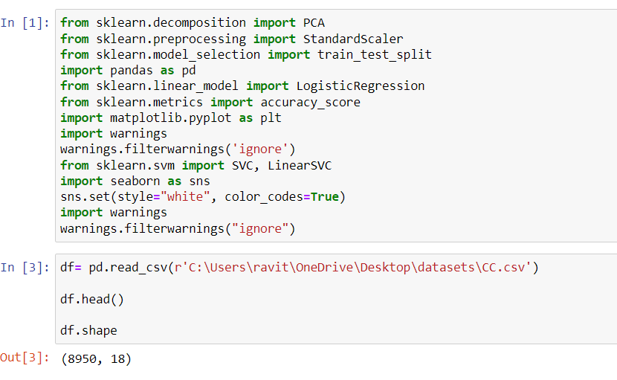

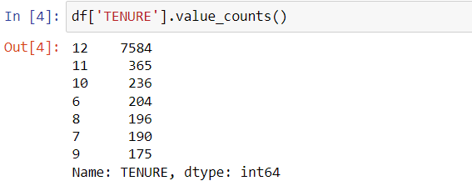

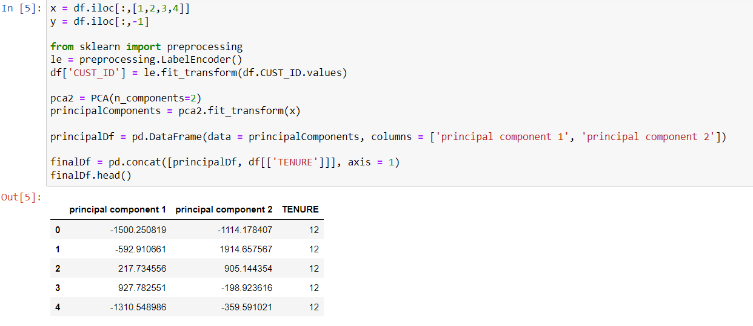

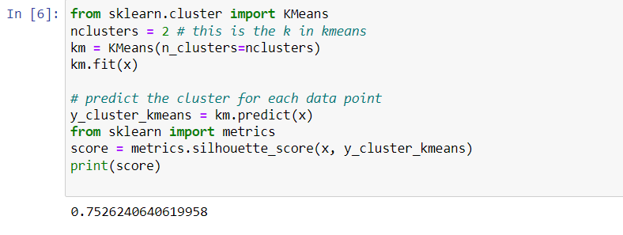

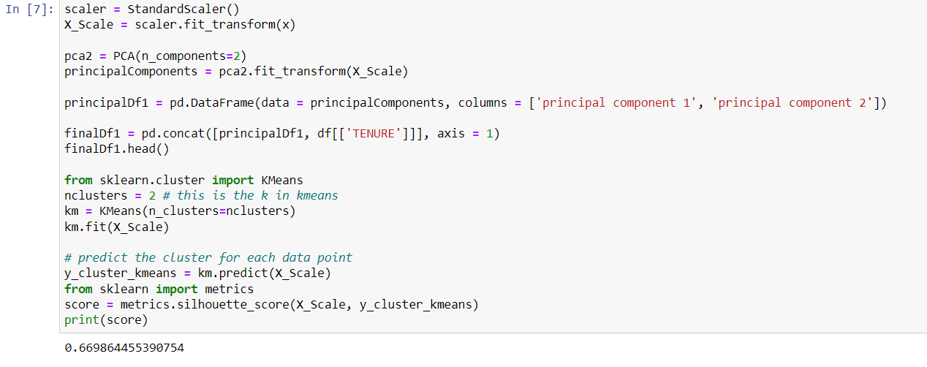

2. Use pd_speech_features.csv

a. Perform Scaling

b. Apply PCA (k=3)

c. Use SVM to report performance

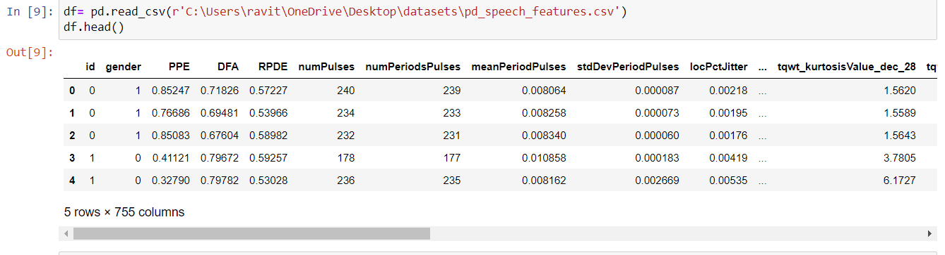

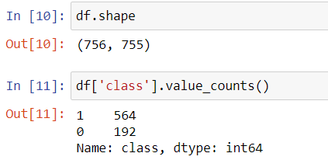

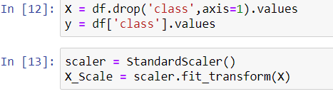

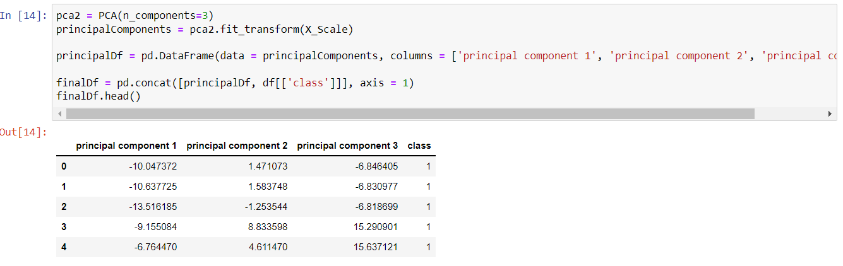

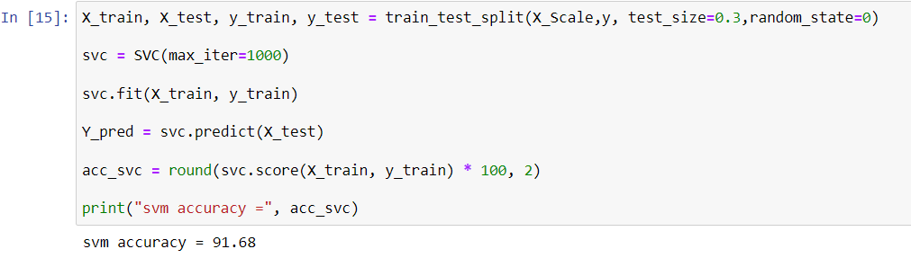

3. Apply Analysis (LDA) on Iris.csv dataset to reduce dimensionality of data to k=2.Linear Discriminant

4. Briefly identify the difference between PCA and LDA

